NLP Project Workflow

Dataset
  - Which dataset will we use?
- Wisesight Sentiment Corpus (Thai) for monolingual Thai sentiment. (26,737)
- SST‑2 (Stanford Sentiment Treebank) for English sentiment. (67,349)

Instances
- Each instance = one sentence/comment.
- Features: raw text, tokenized text, language tags, normalized tokens.
- Labels: sentiment (Positive/Negative/Neutral).

Parameters
- Base model: XLM‑RoBERTa base (~270M parameters).
- Fine-tuning adds task-specific layers (~2k parameters).
- Total parameters used ≈ 270M.

Model
- XLM‑RoBERTa (xlm-roberta-base) is more up-to-date and stronger for Thai compared to mBERT.
- Alternative: XLM‑RoBERTa large (~550M parameters)

Reasons
XLM-RoBERTa (XLM-R) is currently the industry standard for this specific scenario. It was trained on CommonCrawl data in 100+ languages, including Thai and English, making it uniquely qualified to handle code-mixed inputs from above data sources.
  - Shared Vocabulary: It uses a "SentencePiece" tokenizer that doesn't rely on space. It can process Thai characters and English words in the same sequence without breaking.
  - Cross-lingual Transfer: By training on both SST-2 and Wisesight, the model learns that "happy" (EN) and "ดีใจ" (TH) occupy similar vector spaces, which is critical for code-mixed sentences like "I am so ดีใจ today."
  - Performance: It consistently outperforms multilingual BERT (mBERT) because it was trained on significantly more Thai web data.

Input & Output Format
Input format:
- Raw text sequences
- Example: วันนี้ server ล่ม.
Output format:
- Sentiment classification: Positive / Negative / Neutral.
- Confidence score (probability distribution)

Workflow on Colab Notebook
Step 1: Load tokenizer and model
model = xlm-roberta-base
num_labels = 3
Step 2: Load Dataset
Load wisesight and SST-2 Datasets
Step 3: Convert labels to numeric
Wisesight labels: 0: positive, 1: neutral, 2: negative
SST-2 labels: 0=negative, 1=positive -> remap to: 0=positive, 2=negative
Step 4: Combining datasets
Use Wisesight test + SST-2 validation as eval
Step 5: Tokenization and Formatting
- Tokenize Function
- Apply Tokenization
- Format for PyTorch
Step 6: Creating the trainer
- Setting Up Trainer
training_args = TrainingArguments(
save_strategy="epoch",
learning_rate=2e-5,
per_device_train_batch_size=16,
per_device_eval_batch_size=32,
num_train_epochs=3,
weight_decay=0.01,
logging_steps=100
)
- Import metric
- Create Trainer
- Train
- Evaluate
- Save Model

Usage
  - Where will we use that Semantic Analysis Tool?
- Social media monitoring for Thai companies with bilingual audiences.
- Customer feedback analysis where English terms mix with Thai sentences.
- Academic demonstration of handling code-mixed NLP tasks.
  - How are we goanna use that tool?
- Input text → preprocessing (tokenization, LID, normalization) → fine-tuned XLM‑RoBERTa → sentiment output.

Current Progress

Final_Model_v1 with wise-sight and sst2 datasets
Get the correct Sentiment Analysis for Positive and Negative
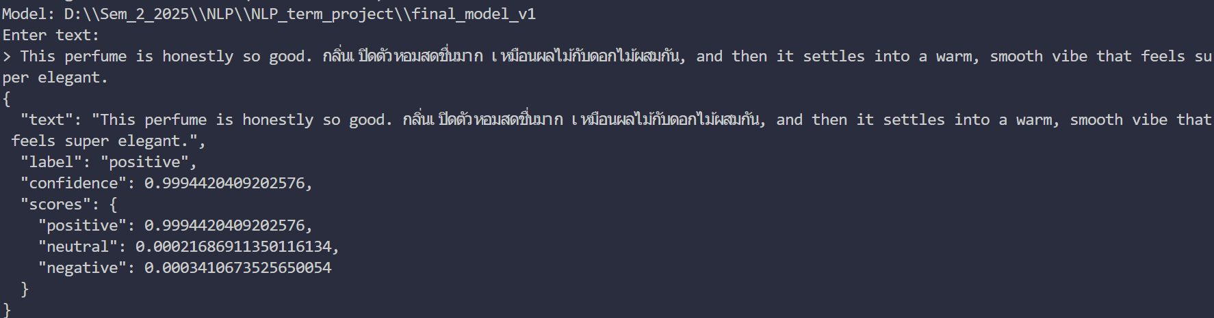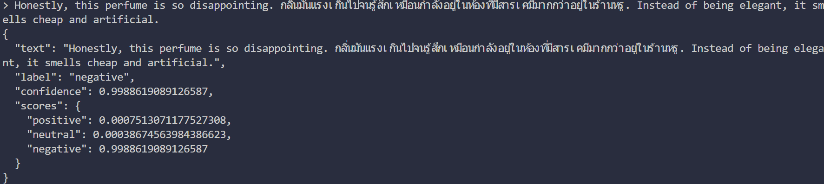
Not getting the correct label for Neutral Sentiment and describing it as Negative
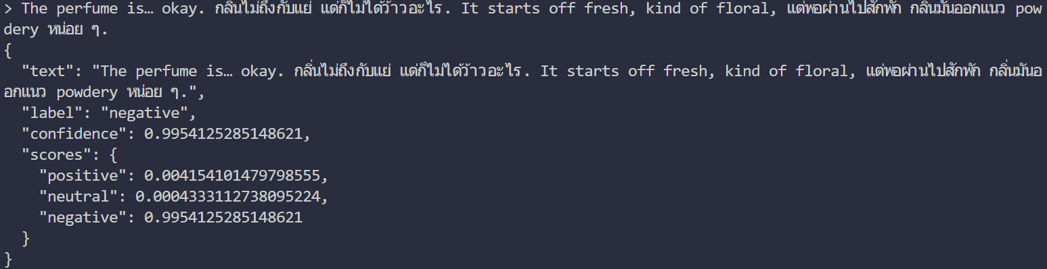

Not treating the question as Neutral
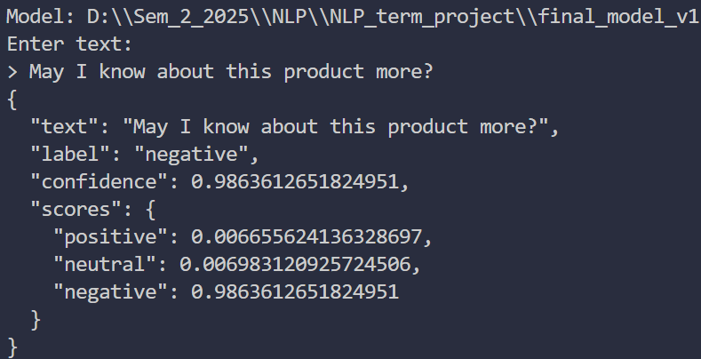

Final_Model_v2 with wise-sight, sst2 and twitter-sentiment datasets
Testing with the same texts
Basically, the same correct Sentiment for Positive and Negative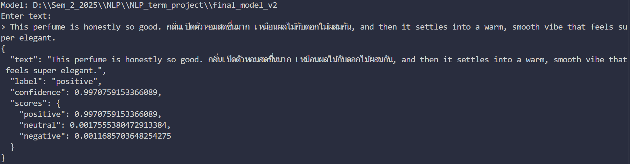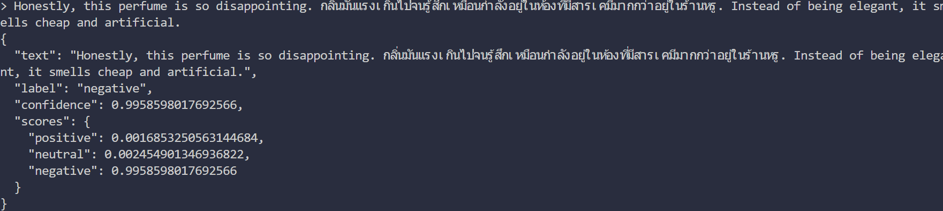

Still negative but improvement in Negative and Neutral confidence scores
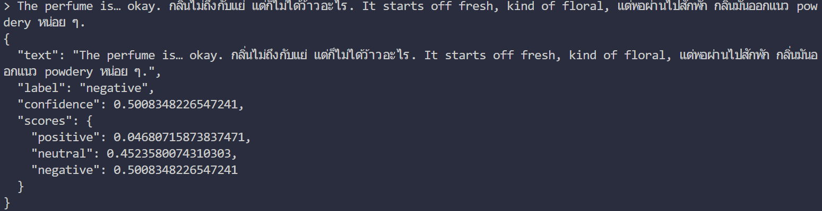
Got the correct Sentiment for some Neutral sentences
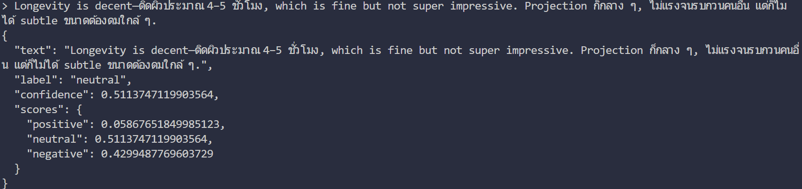
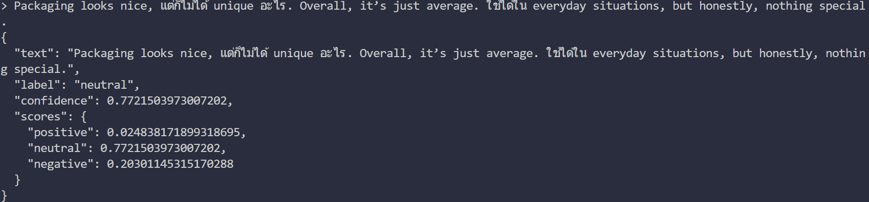
Get the right Sentiment Analysis for Question, treating q as Neutral